**Practical 4:**

**Creating and launching basic virtual machine.**

**Step 1 –** Start VMware Workstation

Open the app after installation. Create a new Virtual Machine.

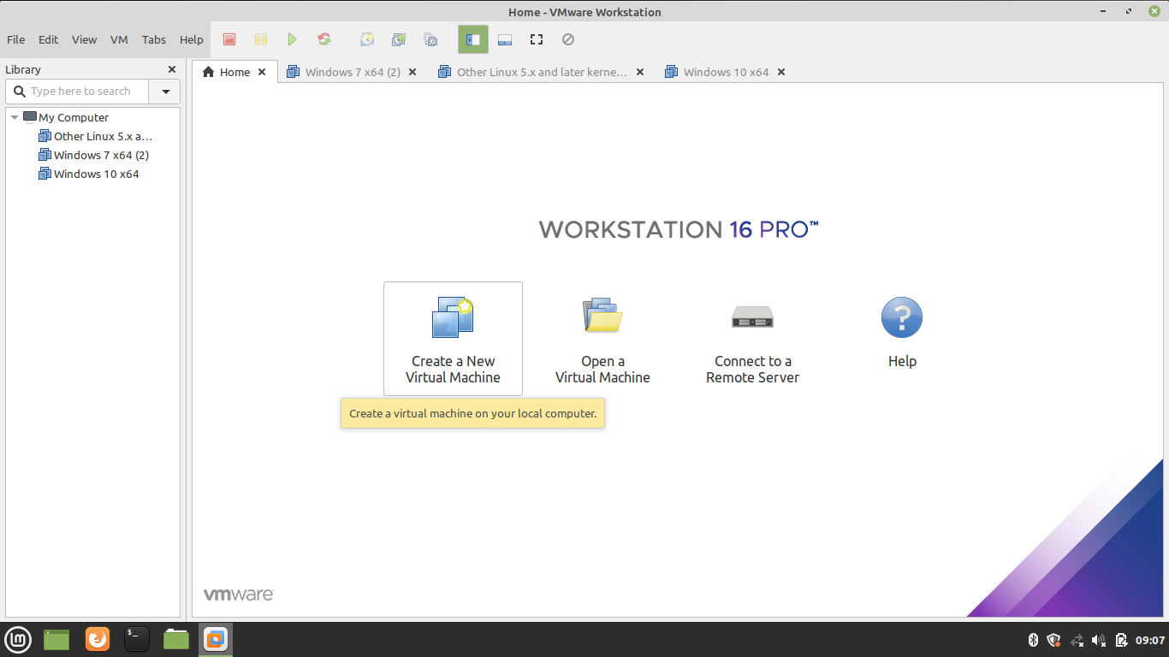

**Step 2 –** Select Custom Configuration Wizard

You can choose either Typical or Custom Wizard. We recommend selecting Custom if you want to install with all the configurations. If you are okay with default configurations then go ahead with Typical configurations.

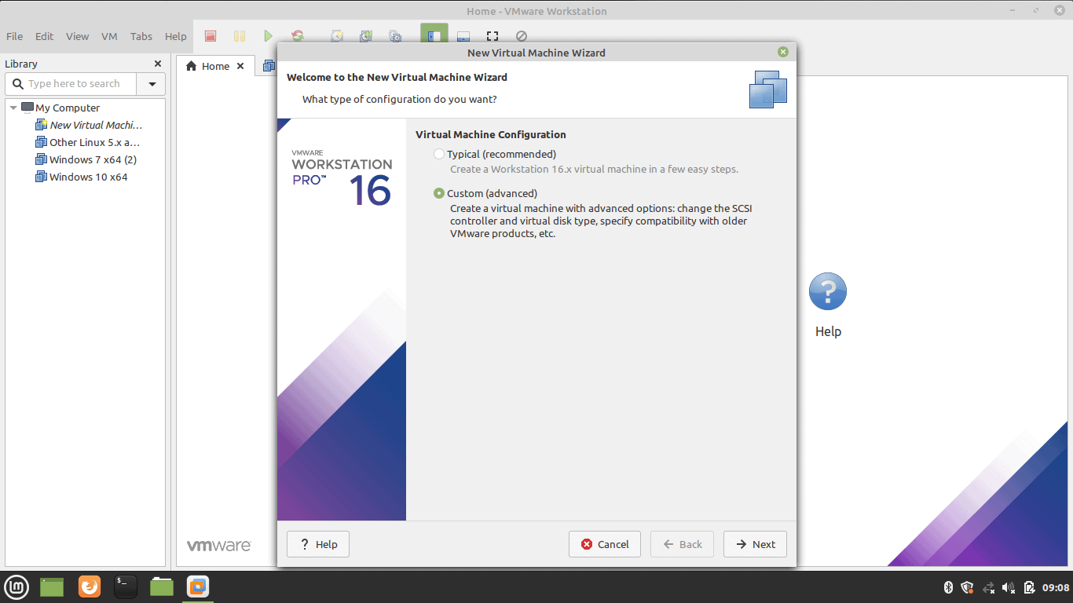

**Step 3 –** Select the Operating System Media

Select ‘I will install the operating system later’ for an interactive installation.

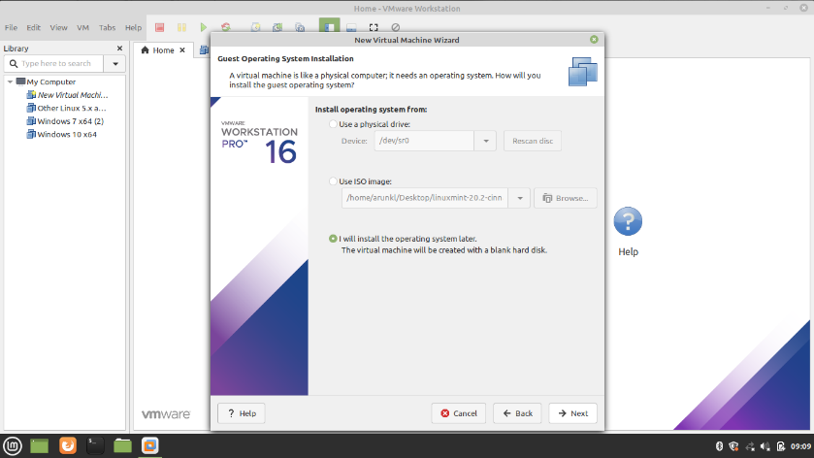

**Step 4 –** Select Guest Operating System

In our case we are selecting Linux operating system.

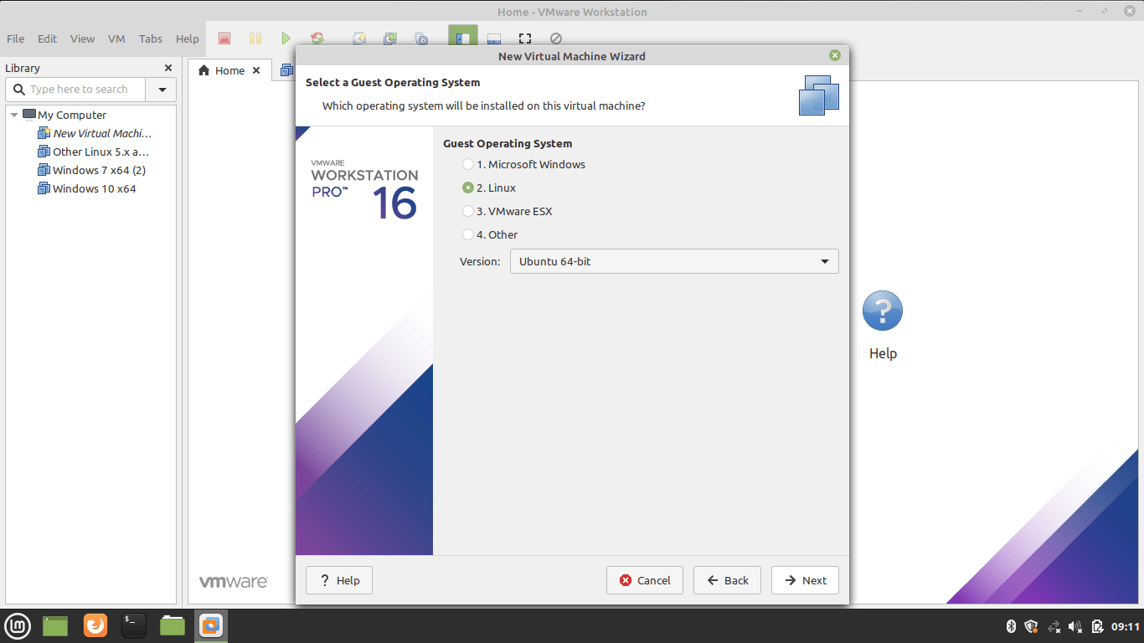

**Step 5 –** Name the Virtual Machine and location

Type a name and give the location details.

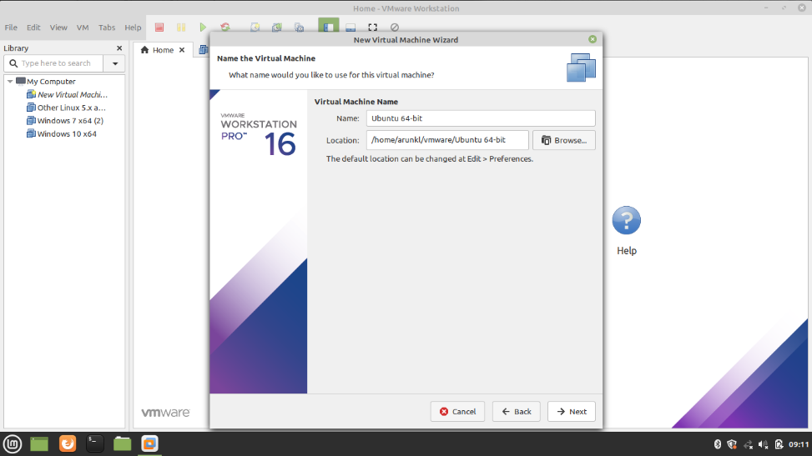

**Step 6 –** Allocate the Processors

Assign the processors, Calculate the processor required to run the host machine. Assign the leftover resources to the virtual machine.

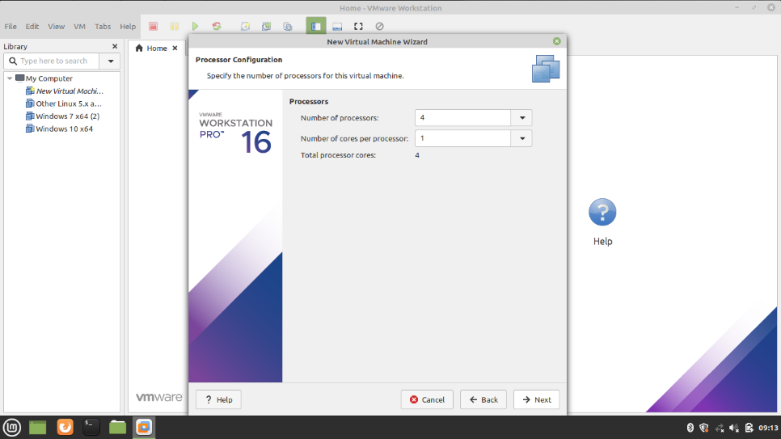

**Step 7 –** Allocate the Memory for Virtual Machine

Memory allocation calculation is the same as the processor allocation. Leave sufficient memory for the host system and allocate the remaining memory for the virtual machine.

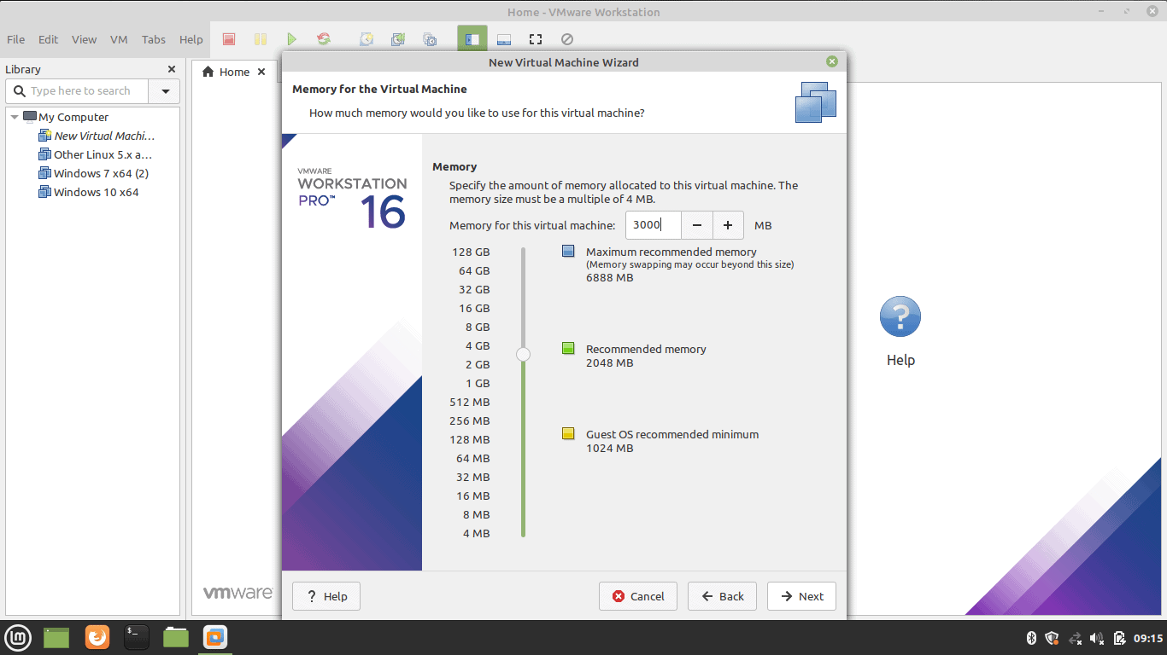

**Step 8 –** Choose the Network Configuration

Select any one of the network configurations as per your requirement.

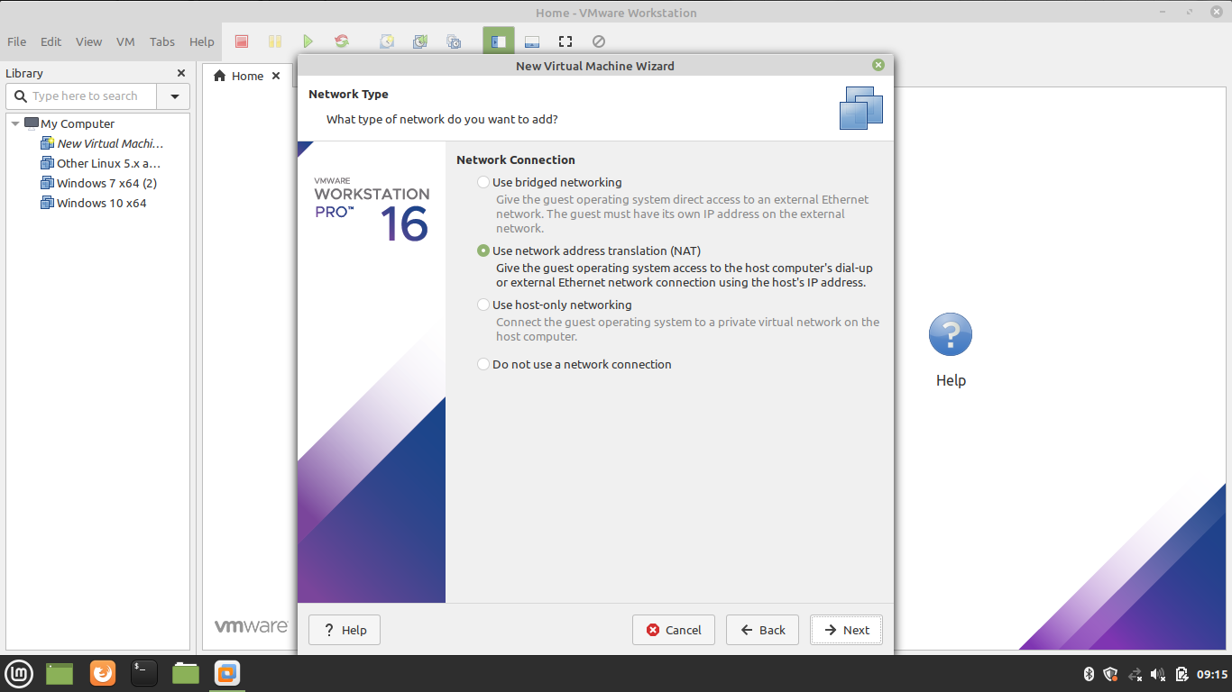

**Step 9 –** Select the I/O Controller Type

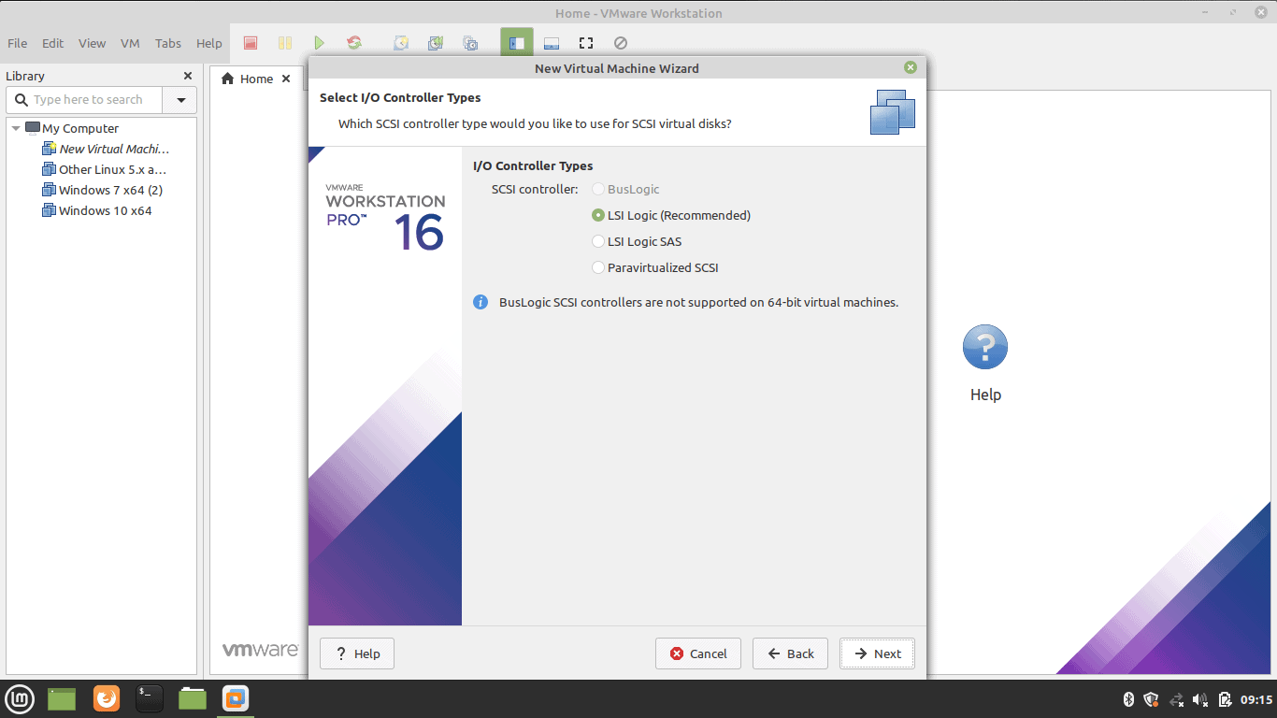

**Step 10 –** Select Disk Type

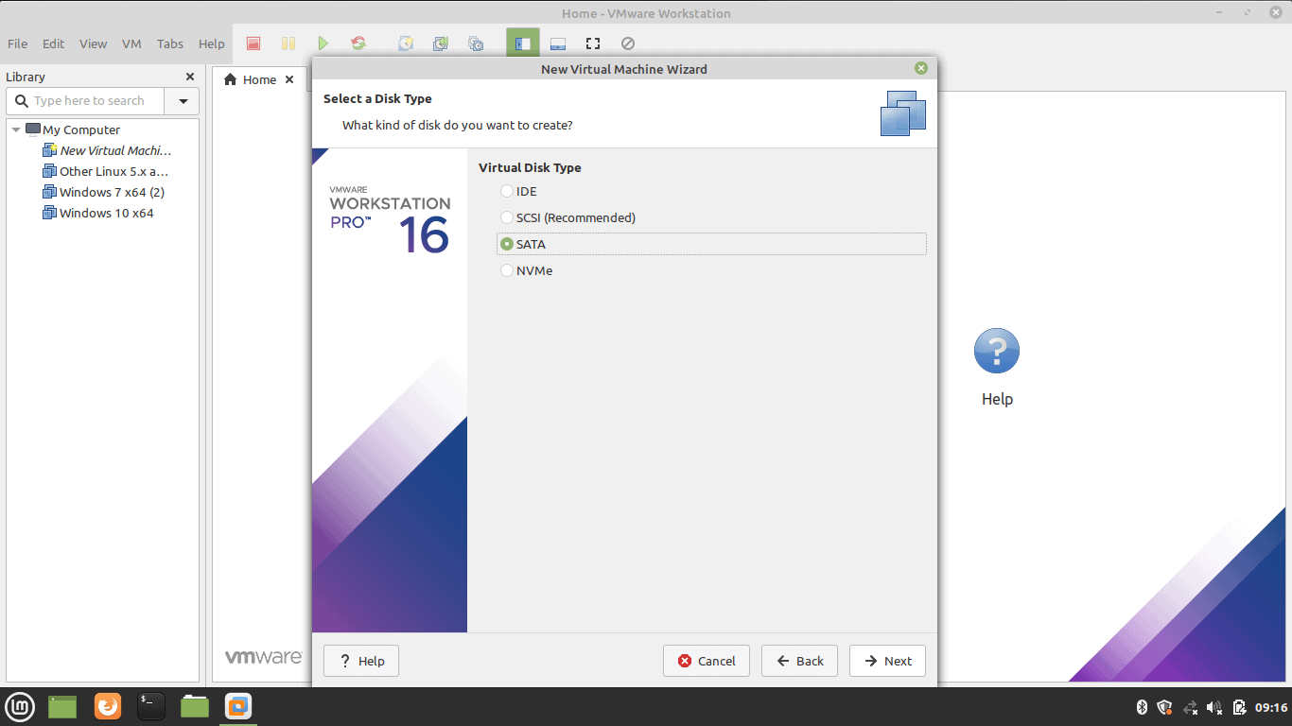

**Step 11 –** Select Virtual Disk

Select the Virtual Disk if you have or create one.

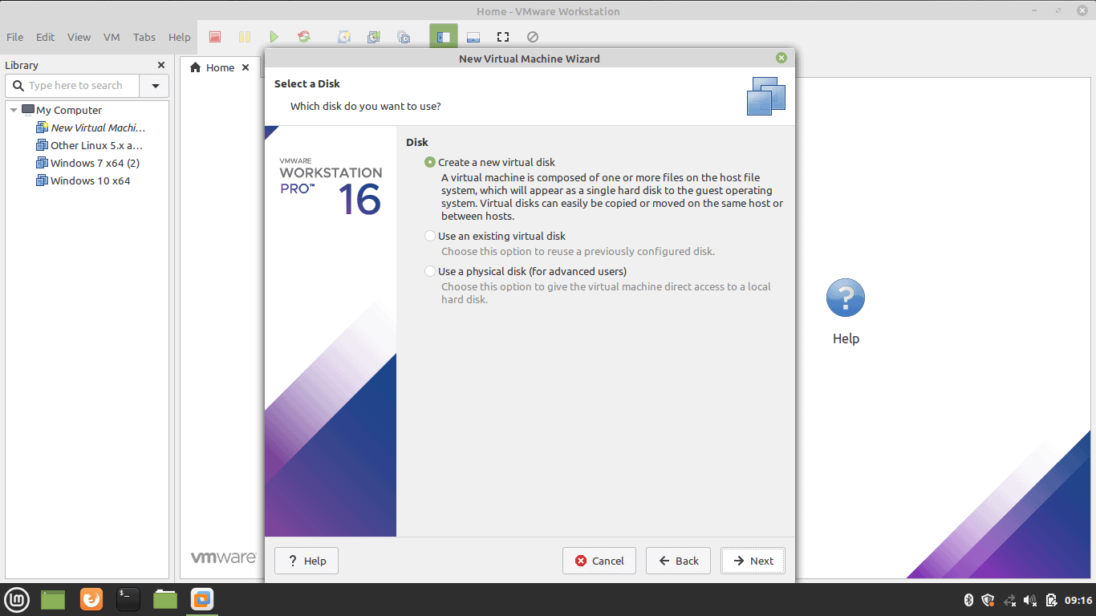

**Step 12 –** Select Disk Capacity

Select the disk size. Selecting a single disk will increase the performance. However, selecting a split disk will help in the disk transfer scenario.

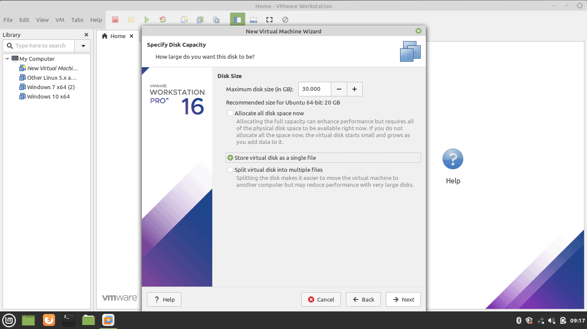

**Step 13 –** Select Virtual Disk File

Select the Virtual Disk File which is usually the iso file of the operating system.

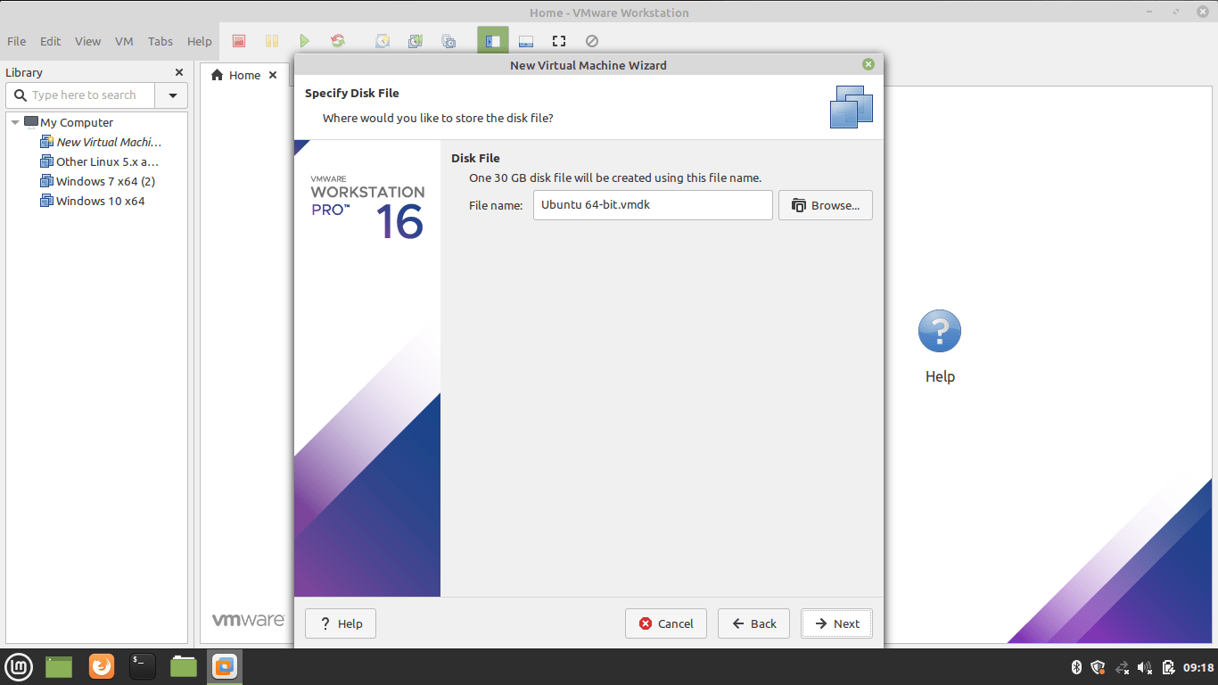

**Step 14 –** Create Virtual Machine

Now click on click virtual machine button

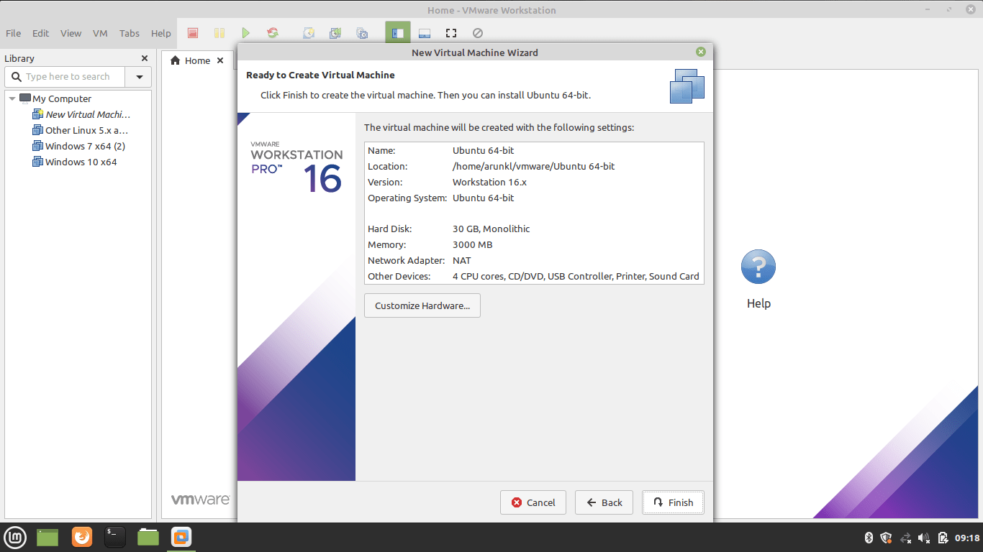

**Step 15 –** Supply Ubuntu ISO Image to Virtual Machine

Download Ubuntu image. Edit the CD/DVD settings and import the downloaded Ubuntu image.

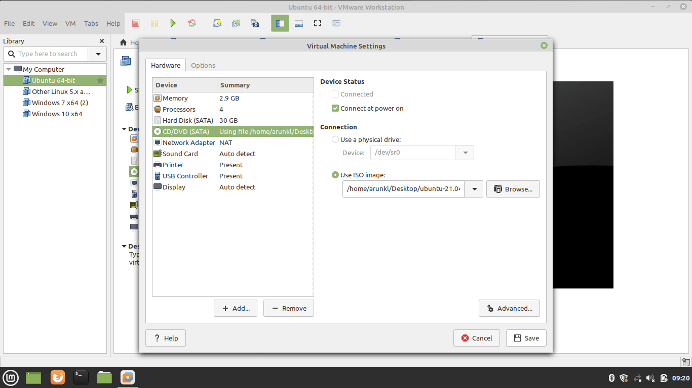

**Step 16 –** Power On the Virtual Machine

Press the Play button to power on the Virtual Machine.

